**Aashram season 3: Release, cast, plot** 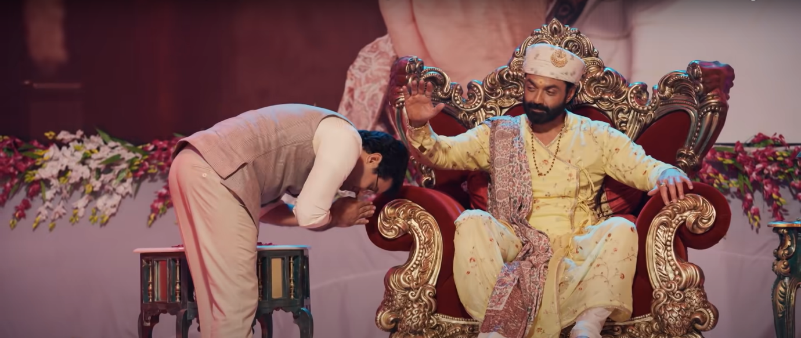

**Aashram**, a hindi-language crime drama web series directed and produced by **Prakash Jha** and streamed on **MX Player**. It was first broadcasted on August 28, 2020. After two successful seasons, leading *Aashram* to be one of the most popular web-series in India, it’s creator and showrunners are eager to start the production for its *third season*.

**Aashram season 3: Probable Cast**

We’re expecting the cast from the first *two season* to repeat their roles. Few actors who’ll be repeating their roles and will make an appearance are:

**Bobby Deol** as **Kashipur waale Baba Nirala**

Tridha Chaudhary as Babita

Aaditi Sudhi Pohankar as Pammi

Darshan Kumar as Ujagar Singh

Anupriya Goenka as Dr. Natasha

Chandan Roy Sanyal as Bhopa Swami

Tushar Pandey as Satti

Vikram Kochhar as Sadhu

Sachin Shroff as Hukum Singh

Anurita jha as Kavita

Rajeev Siddhartha as Akki

Parinita Seth as Sadhvi Mata

Mirza Azhar as Ghaba

Jahangir Khan as Michael

Dimpy Mishra as Girl’s Hostel Warden

Tanmay Ranjan as Dilawar

Anil Rastogi as CM Sundar Lal

Navdeep Tomar as Sunny

Kanupriya Gupta as Mohini

Akanksha Pandey as Renu

Adhyayan Suman as Tinka Singh

Tulika Banerjee as Baba’s Wife

Arpit Mishra as Judge

Akhilesh Tripathi as Baba’s Son 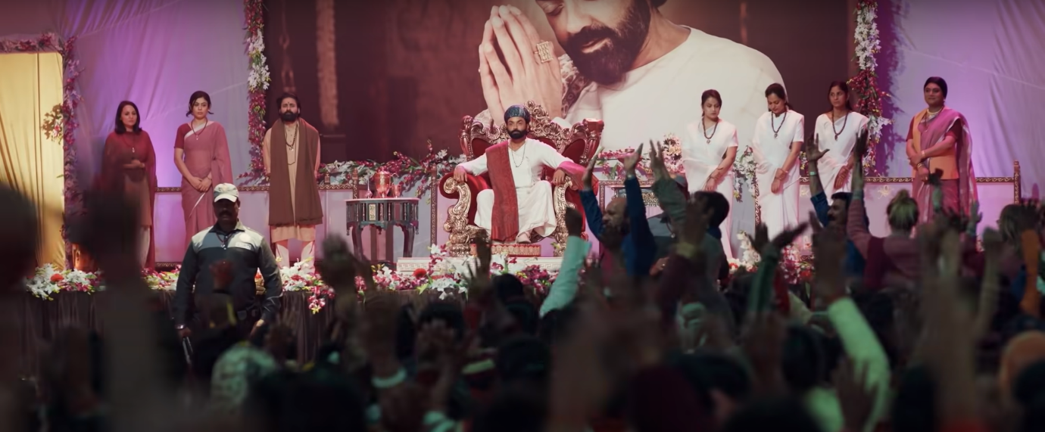

**Aashram season 3: Plot**

The Director and producer of the series revealed that *season 3* will be revolving around *Baba Nirala* character but other characters will be given importance too, there’ll be introduction of few more new characters and few characters will be coming back in this *season* to play their part. *Season 3* will basically be showing the downfall of *Baba Nirala*’s character.

**Aashram season 3: Release Date**

As per the media sources, the shooting for *season 3* is delayed because of covid-19, but still most probably, the shoot will start by March-April 2021. So, we can expect the season 3 to be on the viewers screen by mid 2021. Last year, *season 1* was streamed in August while *season 2* was subsequently delivered in October, 2020 because the shooting for both the seasons were made in one go in Ayodhya. But for *season 3*, even the shooting locations are yet to be decided by the creators. So, we might expect some delay. According to the director of the series, *Prakash Jha*, they’re eagerly waiting for the covid-19 situation to normalise so that they can start their shoots soon.

Till that time, you can enjoy the trailer of the previous two seasons 😊

https://www.youtube.com/watch?v=sr-TLzvHc_k